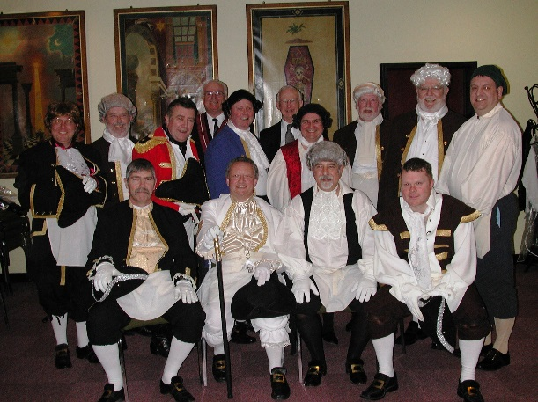
O Yea ! O Yea !
Your opportunity to join the Famous Bunch of Thespians known as: The George and Dragon Players AKA The Demonstration Team for the Masonic Province of Northamptonshire and Huntingdonshire.
In their Exclusive, Hilarious, Productions of
“Lodge Nights 1759, 1760, 1761” See how our ancestors Initiated, Passed and Raised Candidates back then.
“How and Why The Royal Arch” This play tells the story of how The Holy Royal Arch came into being.
and “In The Beginning” Which relates the controversy raging between the Grand Master, The Duke of Sussex, who advocated an annuity and Dr. Crucifix who proposed ‘An Asylum for Worthy, Aged and Decayed Freemasons. This play is eminently suitable for a ‘White Table evening.
–

Enjoy fun evenings with Historical Freemasonry while ‘Advancing your ‘Daily Knowledge’. When you join this happy band of frustrated thespians you will discover the enjoyment of explaining, in action rather than words, the evolutionary manner in which our lovely Organisation has Developed over the years.
This offer is open to all Freemasons from the newest Master Mason to the Grand Master himself.
Entered Apprentices and Fellowcrafts, concentrate on being raised, first.

